Supporting information for

Tryptophan-like fluorescence as a fingerprint of urban river water intrusion into storm drainage system
Hailong Yin ^{a,b,c*}, Yue Wang ^{a,b}, Yang Yang ^{d}, Jingshui Huang ^{e*}, Zuxin Xu ^{b,c}

ª Key Laboratory of Yangtze River Water Environment, Ministry of Education, Tongji University, Shanghai, China, 200092
^{b} State Key Laboratory of Pollution Control and Resource Reuse, Tongji University, Shanghai, China, 200092
^{c} Shanghai Institute of Pollution Control and Ecological Security, Shanghai, China, 200092
^{d} Danish Hydraulic Institute, Shanghai Branch, 4th Floor,Building A, No.181 Guyi Road, Shanghai, China, 200235
^{e} Department of Aquatic Ecosystem Analysis and Management, Helmholtz Centre for Environmental Research – UFZ, Brückstraße 3a, 39114 Magdeburg, Germany

*Corresponding author. E-mail address: yinhailong@tongji.edu.cn; huangjingshui@126.com

S1. EEMs of domestic sewage samples
Detected EEMs for all of the 18 domestic sewage samples were shown in Fig.S1. Fig.S2 presented fluorescent peak intensities of tryptophan-like T₁ and T₂ for each sample.
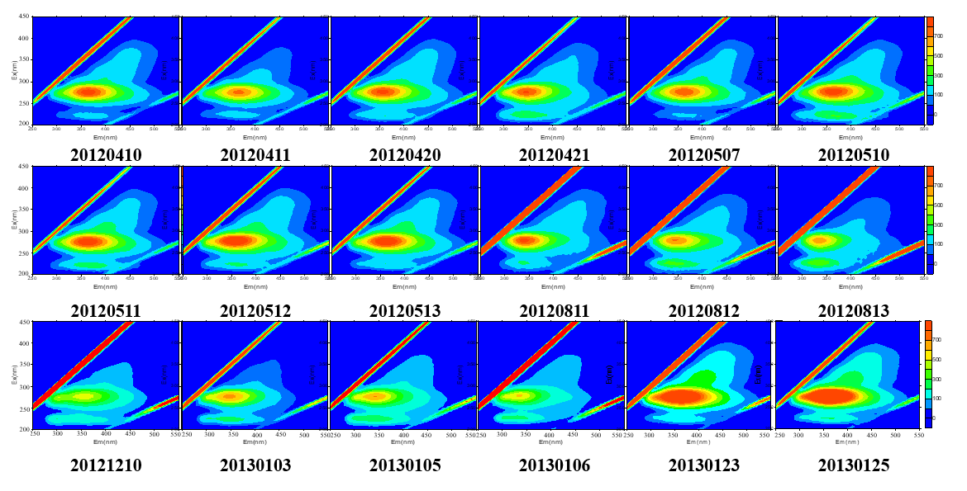
Fig.S1 Detected EEMs for the domestic sewage samples
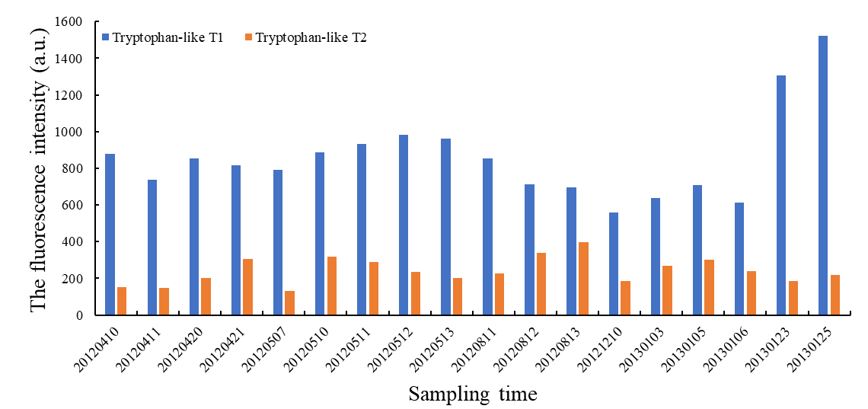
Fig.S2 Fluorescent peak intensities of tryptophan-like T₁ and T₂ of domestic sewage samples

S2. EEMs of urban river water samples
The EEMs for all of the collected river water samples (i.e., 15 sampling activities and 90 river water samples) over the temporal and spatial changes were shown in Fig.S3.
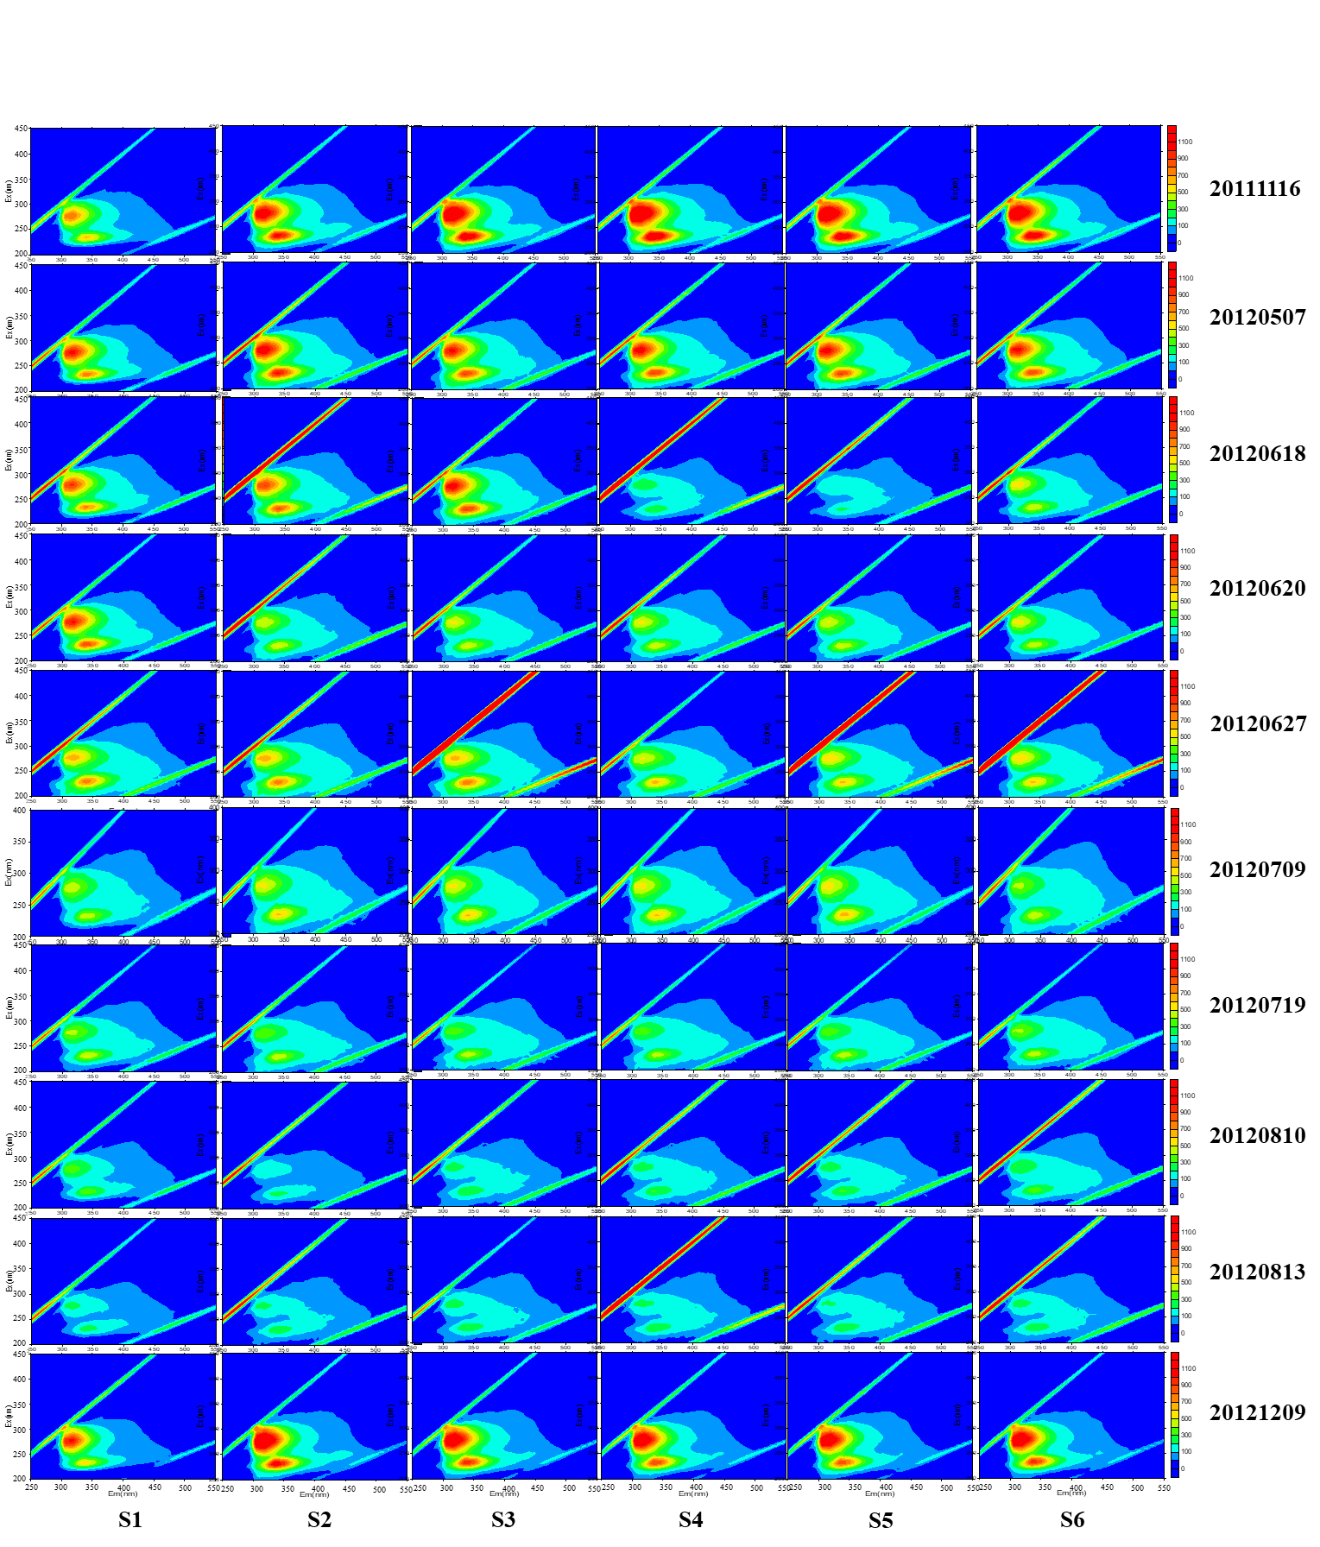

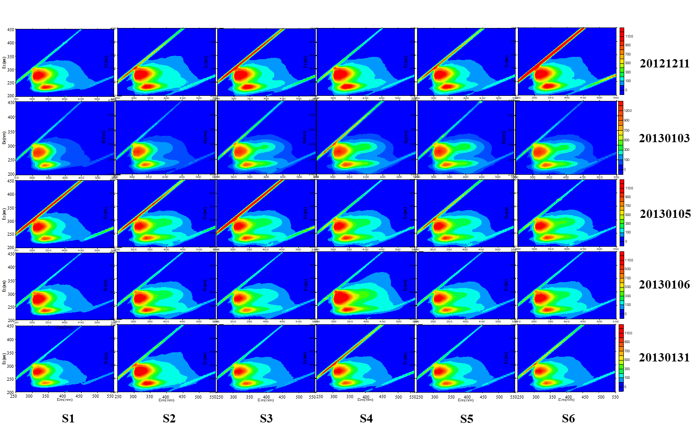
Fig.3 Detected EEMs for the urban river water samples

S3. Changes of EEMs with experimental duration
Changes of EEMs with the experimental duration for domestic sewage and urban river water were listed in Fig. S4 and S5 respectively.
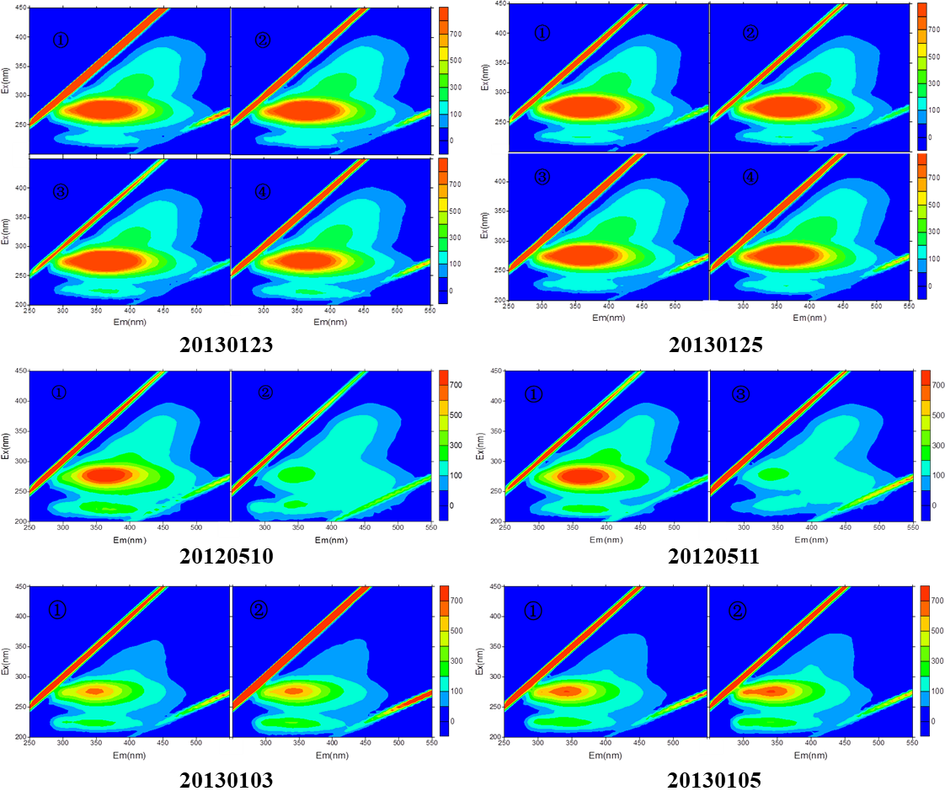
Fig.S4 Changes of EEMs for the domestic sewage with the experimental duration

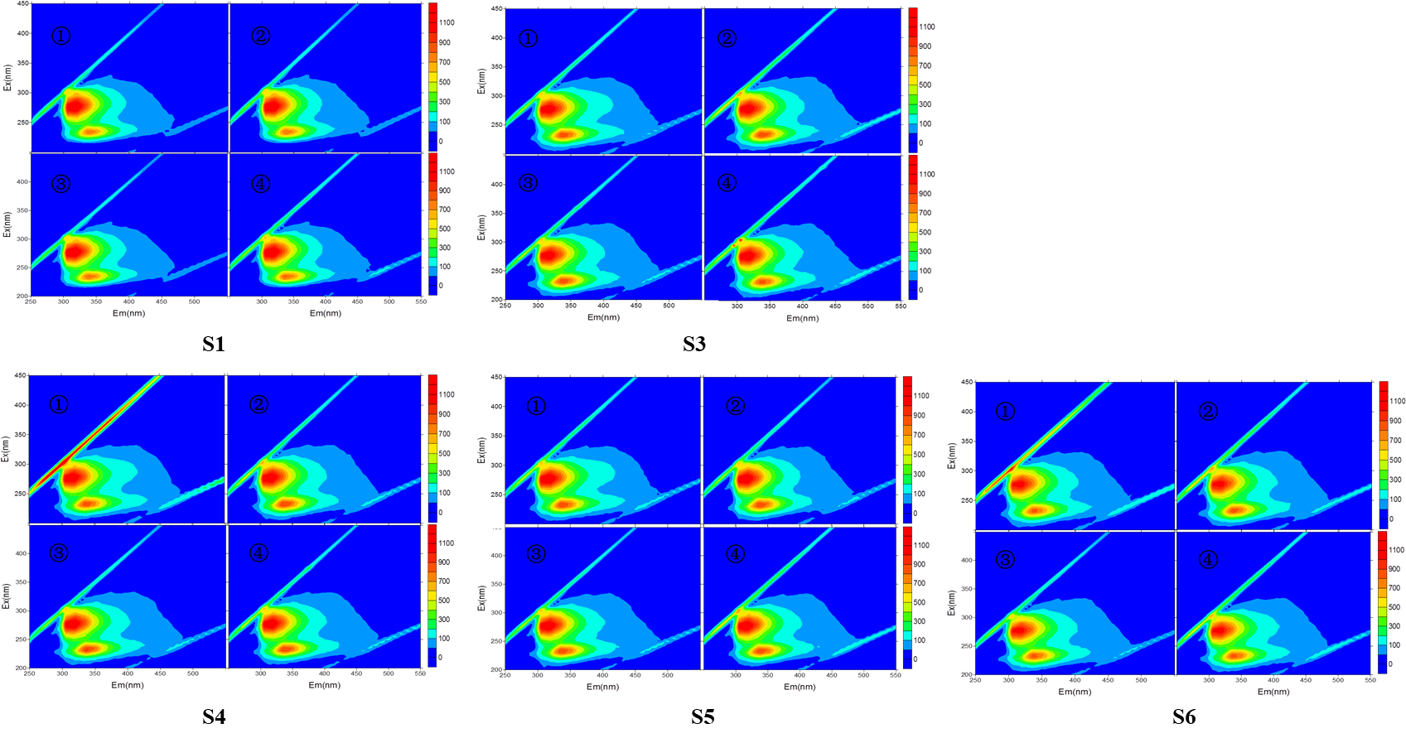
Fig.S5 Changes of EEMs for the urban river water with the experimental duration
S4. EEMs of catchment outflow
Detected EEMs for all of the 12 catchment outflow samples were shown in Fig.S6. Fig.S7 presented the fluorescent peak intensities of tryptophan-like T1/T2 and tyrosine-like B₁ of each sample.
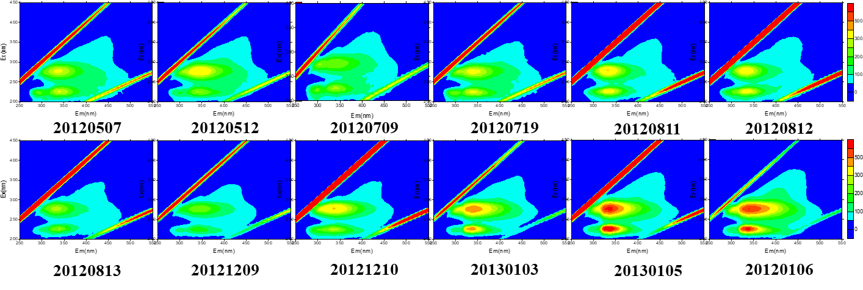
Fig.S6 Detected EEMs for the catchment outflow samples

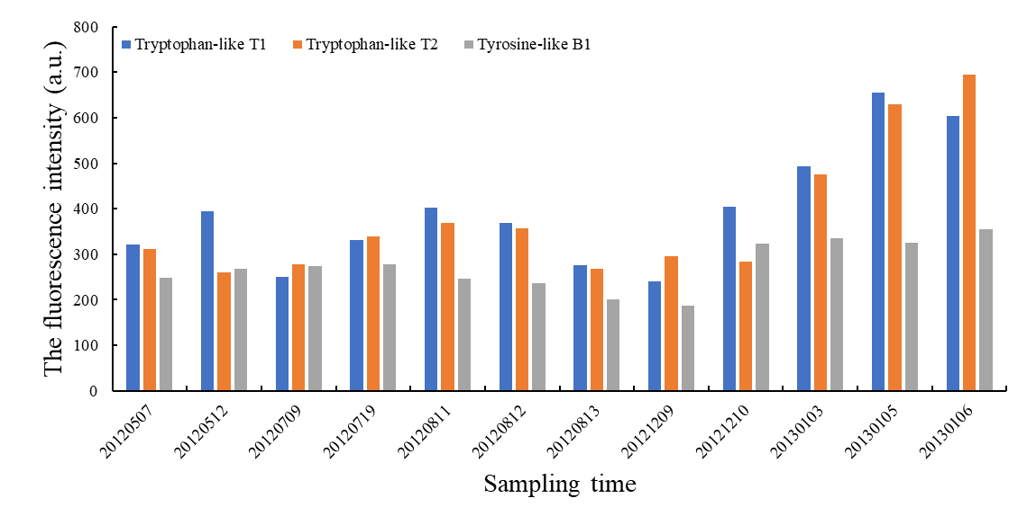
Fig.S7 Fluorescent peak intensities of tryptophan-like T1/T2 and tyrosine-like B₁ for the catchment outflow samples.

